Desirée Holman:
Telling Stories with Masks

In this project, you will create a mask that represents a character of your own invention. The character can be anything you imagine: from an average person to an extraterrestrial. It’s up to you! Whatever you choose, think about who that character is, and how they live their life. After the masks are completed, you will be paired with a partner who will be chosen at random. You and your partner will then ‘introduce’ each other to your respective characters, and create your own story for these characters. Together, you can decide how to introduce these characters to the rest of the class. You and your partner can present the characters separately or together.

This project should be executed over the course of at least 4 separate sessions.
Session 1: Making Your Mask, Part 1
Media:
Sculpture, performance, and video (optional)
Materials:
Balloons
Recycled newspaper and/or printer paper
Flour
Water
Shallow trays for mixing paste
Wooden or plastic mixing sticks
Large, clean yogurt containers
Needles
X-ACTO knife
Scissors
Ribbons, cording, elastic, or rope to hold up mask

Additional materials for decorating:
Paints and brushes
Markers
Fabric pieces
Glue

Session 2: Making Your Mask, Part 2
Session 3: Creating Your Character
Session 4: Presenting Your Character

Session 1: Making Your Mask, Part 1
  - To prepare, start by thinking about the character you want to create. You can start with a clear vision of this character or you can let it emerge through the process of making the mask. Will your character mask be scary, wacky, or refined?
  - Next, spend some time researching masks online, with a special focus on those made with papier-mâché. Think about what you want your papier-mâché mask to look like.
  - Prepare your work area and gather your materials. It is recommended that you cover your working surface with old newspaper to avoid getting the table dirty.
  - Prepare your papier-mâché materials:
      - Inflate and tie off a balloon sized just a little larger than a human adult head. The balloon will provide the shape for your mask.
      - Rip or cut the recycle newspaper and/or print paper into various shapes, e.g. strips, triangles, and squares.
      - Create a paste by mixing together 2 cups flour and 1 cup water.
  - Build the masks:
      - Dip the paper into the paste and let it soak in the paste. Be sure to wipe off excessive paste from the paper and then cover the balloon with these papier-mâché pieces.
      - Use a minimum of 5 thin layers of papier-mâché paper, alternating the direction of how the paper is adhered.
      - Mold on extra features and shapes as you see fit.
      - It may be helpful at this point to stabilize the mask by proving it up in the opening of a larger yogurt container.
      - Let your mask dry overnight.

Session 2: Making Your Mask, Part 2

  - Holding the balloon by the tied-off end, pop it with a needle and pull it out.
  - Using scissors or an X-ACTO knife, cut the papier-mâché sphere in half. If desired, cut eye, mouth and nose holes.
  - Alter the mask to fit. You may be able to gently mold it to fit the shape of your face. Use extreme caution here so as to not crack the mask. Remember, the mask may be worn.
  - Securely attach ribbons, cording, elastic, or rope so that the mask may be worn.
  - Decorate the mask using whatever materials you wish.

Session 3: Creating Your Character

  - Pick a partner at random. The ideal partner is someone you don’t know well.
  - Get together with your partner—ideally in a semi-private place—and take turns introducing each other to the characters you have both created with your masks. Ask each other questions about your respective characters. It’s fine to work together to figure out details about who each of your characters are.
  - Together, create a short story/stories, poem, or song/rap about each character. You can either create two different short stories for each character or one story in which both characters are involved. Think about how you might like to present your story/stories, poem, or song/rap. Should you wear the mask? Should you bring in props from home to tell the story? Should you wear a special outfit?
  - Practice telling the story with your partner. Take notes if you need to help yourself remember.

Session 4: Presenting Your Character

  - With your masks and props (if any), take turns presenting your stories to the class.

Artist Biography:
Desirée Holman
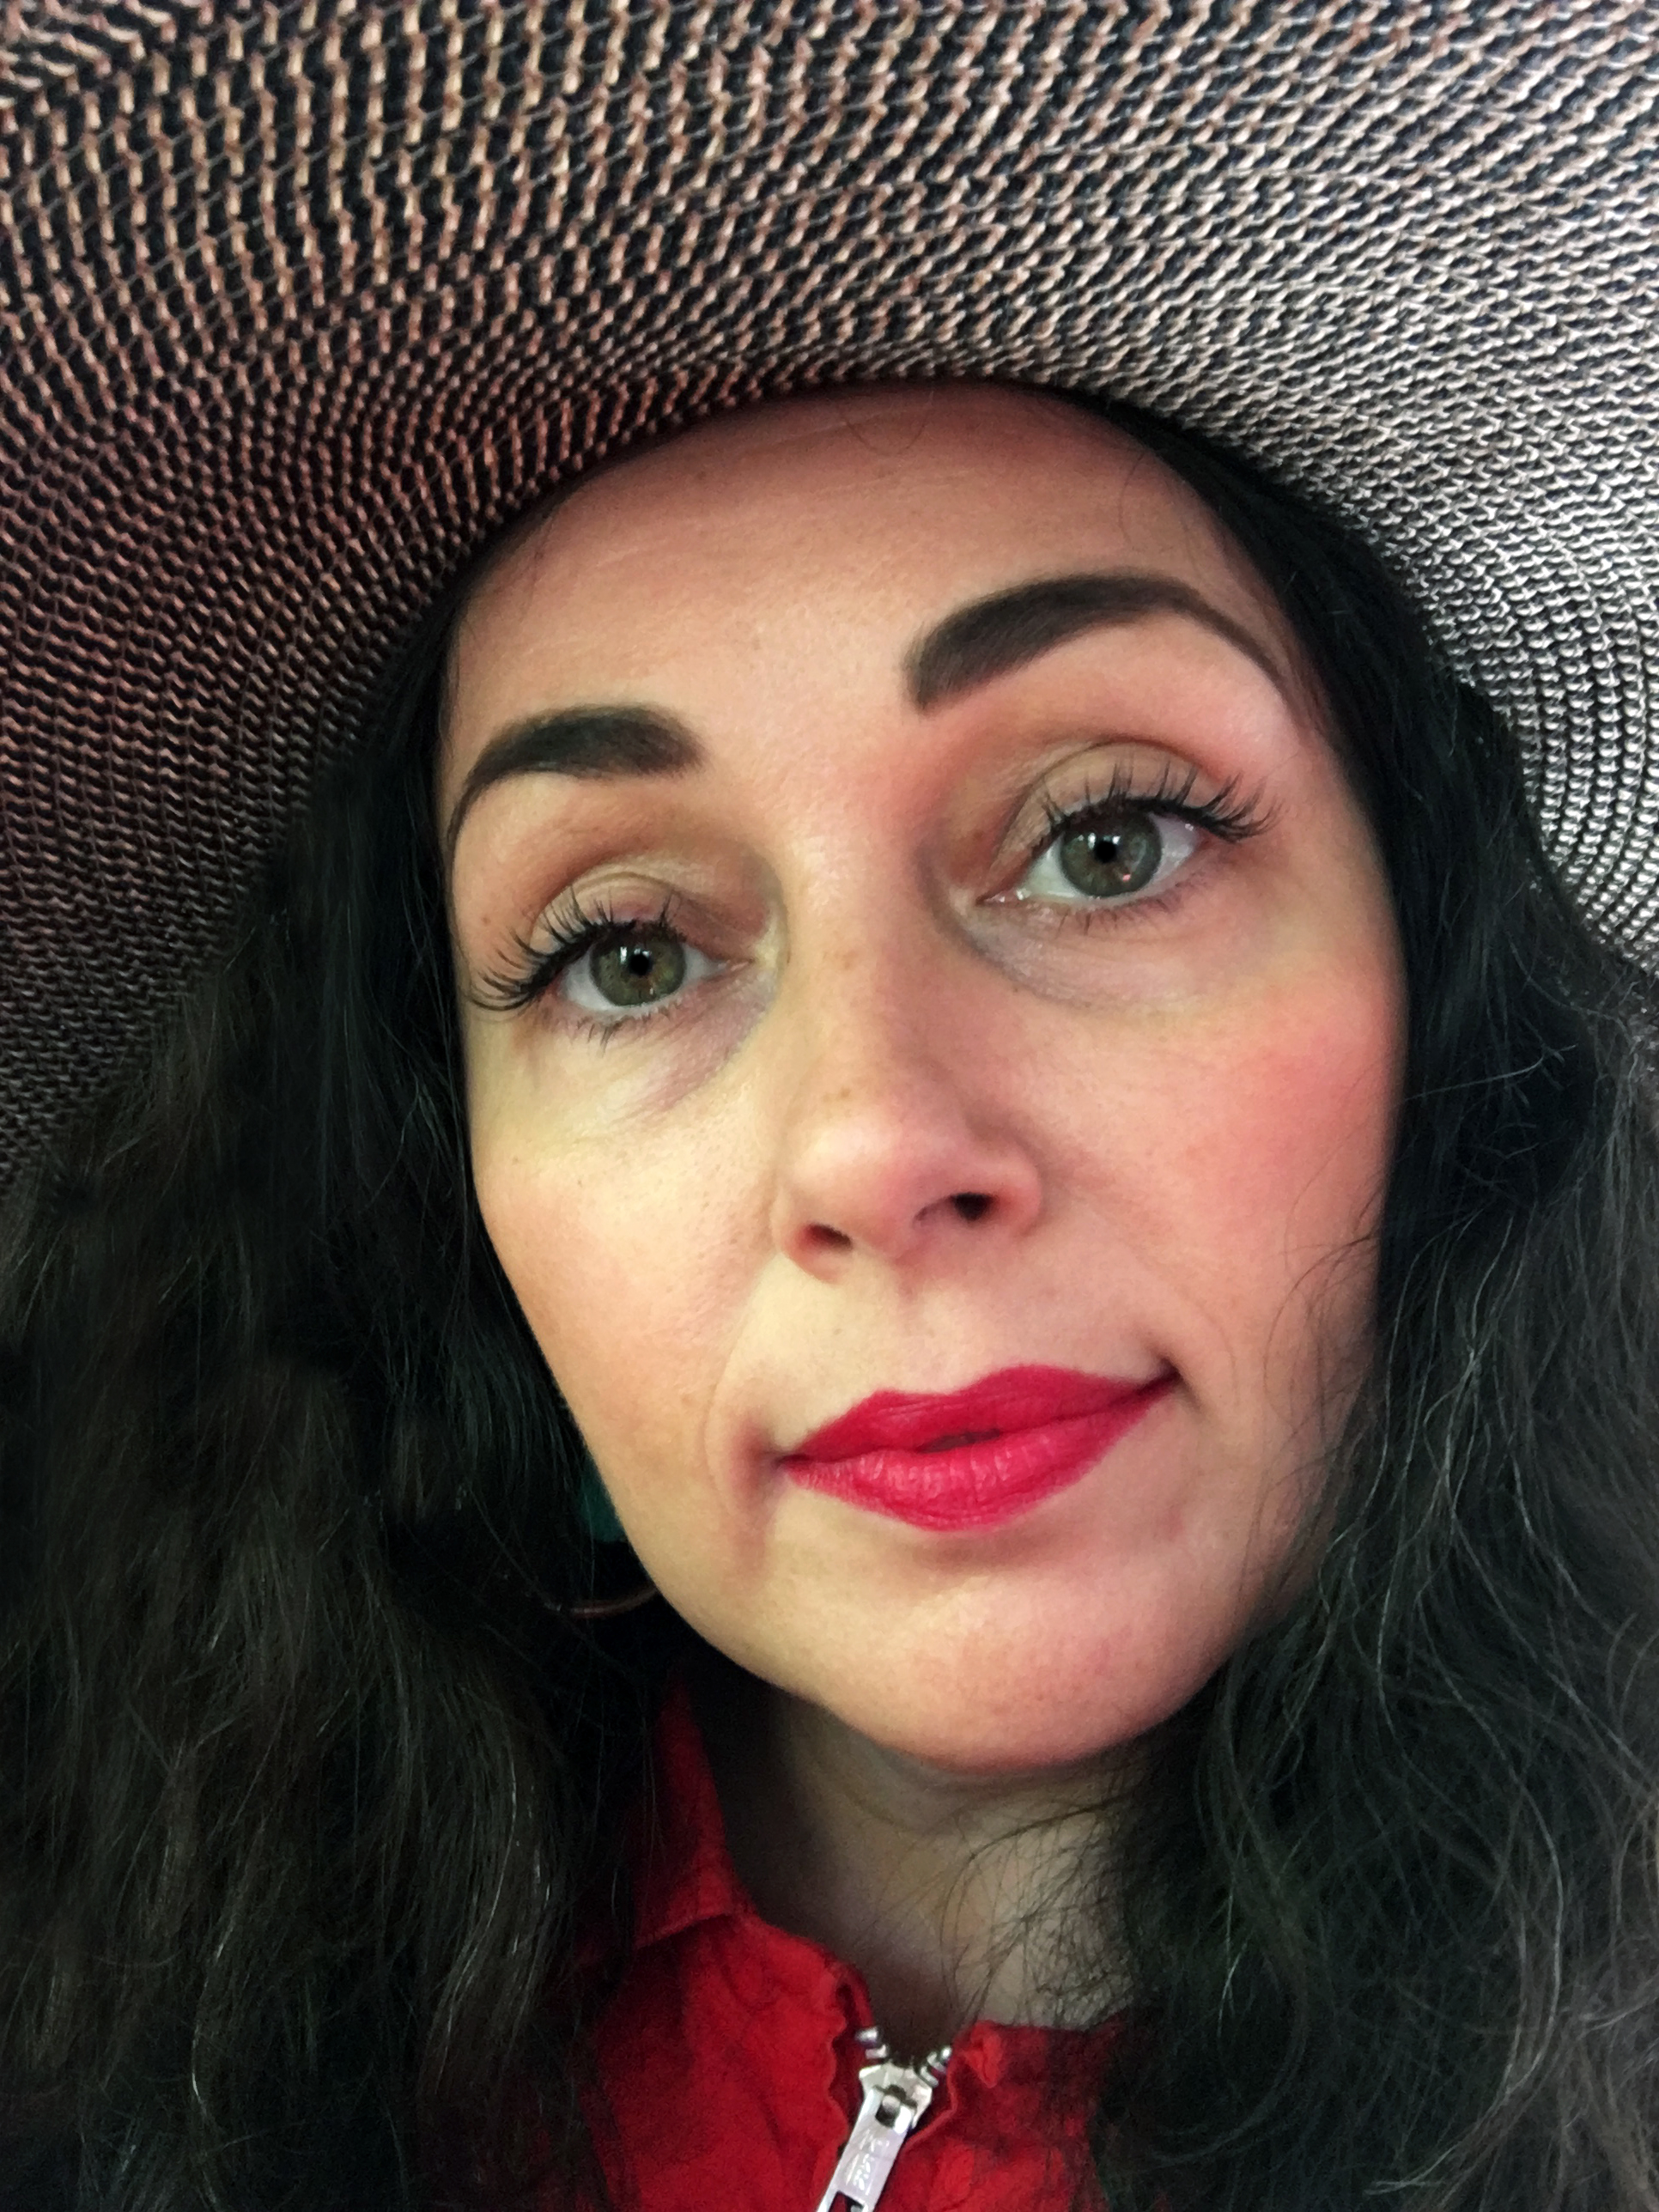Desirée Holman

Born in 1974 in Montgomery, Alabama.
Currently lives and works in Oakland.

Desirée Holman’s multi-sensory work positions groups of individuals and theatrical tools, like costumes or props, in settings that illuminate ideas of identity. Holman uses pretend play as a way to explore difficult-to-discuss matters, particularly with regard to social stratifications and divisions. Holman holds a master’s degree from the University of California, Berkeley. Earning critical acclaim for her work, Holman was awarded a San Francisco Modern Museum of Art SECA award in 2008 and received the Artadia: The Fund for Art and Dialogue Award in 2007. From 2016–2017, she will be returning to SFMOMA as a fellow in the Film and Performance Department with a new work commission. Solo exhibitions of her work include the Hammer Museum, Los Angeles (2009); SKOL, Montreal (2016); Black Cube Nomadic Museum, Denver (2015); and Berkeley Art Museum’s MATRIX program (2011). International exhibitions of Holman’s include the São Paulo Museum of Modern Art; Künstlerhaus Bethanien, Berlin; BnD Denver; and YYZ, Toronto.

