Hung Liu’s Look, Record, Explore:
Drawing small things around you

When I am beginning a painting I shuffle my collection of photographs, just looking at them over and over again. I take them on trips, especially long flights, from California to New York, from San Francisco to Beijing. A lot of the time I also bring a sketchbook. I just quickly sketch, thinking, what if I were to do this painting eight feet tall? These assignments ask you to look closely at the world around you and use drawing and photography to visualize new perspectives.
Media:
Drawing and photography
Materials:
+ Paper
+ Pencils
+ Pens
+ Erasers
+ Smart phones
+ Acrylic or tempera paint
+ Ink
+ Paintbrushes
+ Everyday objects

Assignment #1
Take a five-minute walk outside of your classroom. Pick up an object that you find to be of interest, such as a twig, a rock, a leaf, or even a piece of trash. Draw the object.
Assignment #2
Team up with a partner and draw each other’s profiles using only your shadows. Now change the distance of the light source and draw the shadows again.
Assignment #3
Outline one of your hands on a piece of paper. Next, add as many details as possible to the hand.
Assignment #4
Outline one of your feet on a piece of paper. Next, add as many details as possible to the foot.
Assignment #5
Make a drawing of one of your shoes. Next, choose a partner and trade your shoe with one of his or her shoes. Make drawings of each other’s shoes and compare the final results.
Assignment #6
Make three self-portraits using the following source material:
- Photo Identification card (student I.D., driver’s license, etc.)
- Photo of self (cell phone photograph, online profile picture, snapshot)
- Your reflection in a mirror
Assignment #7
Make a drawing of a jacket or shirt on a hanger. Next, make a drawing of the same jacket or shirt being worn by someone.

Assignment #8
Draw an object from an unconventional angle or perspective. Here are some examples: keys, cell phone, bicycle, computer, book.
Assignment #9
Create an Action Painting. Think of different ways to move your body to create unique patterns and forms with paint. Next, create a group Action Painting with a few partners. Compare the different paintings.
Assignment #10
“Outside & Inside.” Draw a piece of food or another object from the outside. Next, cut the object in half and draw a cross-section of the object.
Assignment #11
“Zoom In / Zoom Out.” Using a smart phone, take several pictures of an object or space. Using the zoom feature on the phone, take some pictures zoomed all the way “in” and some zoomed all the way “out.” Use these features to render things in an alternative or abstract way.

Artist Biography:
Hung Liu
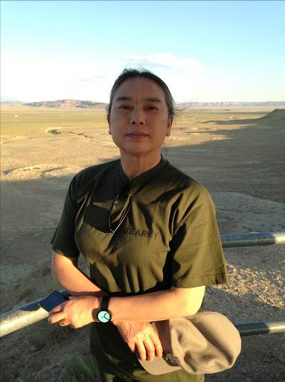Photo: Jeff Kelley

Born in 1948 in Changchun, China
Currently lives in Oakland, California
Born the year before the founding of the People’s Republic of China, Liu experienced the Cultural Revolution first hand. Initially trained in the Socialist Realist style, she studied mural painting as a graduate student at the Central Academy of Fine Art in Beijing before immigrating to the U.S. in 1984 to attend the University of California, San Diego, where she studied with Allan Kaprow.
As a painter, Liu challenges the documentary authority of historical Chinese photographs by subjecting them to the more reflective process of painting. Much of the meaning of Liu’s painting comes from the way the washes and drips dissolve the documentary images, suggesting the passage of memory into history while working to uncover the cultural and personal narratives fixed—but often concealed—in the photographic instant. She has written: “I want to both preserve and destroy the image.”
A two-time recipient of a National Endowment for the Arts Fellowship in painting, Liu also received a Lifetime Achievement Award in Printmaking from the Southern Graphics Council International in 2011. A career retrospective of Liu’s work, Summoning Ghost: The Art and Life of Hung Liu, was organized by the Oakland Museum of California and is scheduled to travel to other museum venues into 2015. In a review of the retrospective, the Wall Street Journal’s David Littlejohn called Liu “the greatest Chinese painter in the U.S.” Liu’s works have been exhibited extensively and collected by the San Francisco Museum of Modern Art; the Whitney Museum of American Art, New York; the Metropolitan Museum of Art, New York; the National Gallery of Art, Washington, D.C.; the Asian Art Museum, San Francisco; and the Los Angeles County Museum, among other institutions. Liu currently lives in Oakland, where she has been a professor of art at Mills College since 1990.

