Nigel Poor’s Observing Self:
Collecting life’s remnants

My work explores various ways people make a mark and leave behind evidence of their existence. I am interested in the portrait and self-portrait and explore this area through unconventional means. I have used fingerprints and hands, washed books, objects people have thrown out, human hair and dryer lint, flies and dead insects collected from the front of my car as markers of human presence and experience. My interest in the question of how to document life and what is worthy of preservation sometimes leads me to engage in projects that may at first blush sound absurd. I like to use everyday materials, humble things that many might overlook. I find that in the quiet of the everyday there is the possibility of answering or at least engaging in life’s most perplexing questions.
I tend to commit to time-based projects. What I am sharing with you is based on shortened versions of my own endeavors. For each project I am suggesting a commitment of seven days, but if you can do longer, that is terrific! The objective of these activities is to slow you down, help you to be more aware of your surroundings, and encourage you to see the surprise in everyday experience.
Media:
Found objects, actions, places, time

Project #1: The Walk
We are going to start off easy and build the complexity of the project as you move forward through each activity. To begin, all you are going to do is take a walk every day for SEVEN days. But on that walk you are going to leave behind all electronic devices—no phone, no music, no friends, nothing to distract you. Your walk can be anywhere and can be done at any time of day. Simply walk in silence until you find something on the ground that interests you. Once you pick up that object, you have to commit to it. You cannot exchange it for something you might find later. It is your object for the day. Remember, you should walk until you find something; it might take you a few minutes or it could take an hour. At the end of the week your task is to create something with the seven objects you found.
I did a version of this project for one year and I ended up photographing each object against a black background and exhibiting the photographs in grids that mirrored the calendar form. You don’t have to use photography; you could make a sculpture or perhaps a collage. The important part is to create something with your findings.
Media:
Actions, time
Materials:
+ Camera
+ Printer or computer for viewing final images

Project #2: Daily Action
Have you ever thought about how a daily activity gives away clues as to who you are, what you value, how you see the world? For this project you are going to be a private detective doing surveillance on yourself. You are to select a daily activity to investigate and archive. Think about something you do every day, something that is essential to your life but that may also be done in a mindless kind of way. You are going to photograph this action every day for SEVEN days straight. The action must be documented in TWO ways:
- The action itself
- The result of that action
Photographing the action is pretty straightforward, but thinking about how to photograph the “result of the action” is more complex. To do this part, think about evidence: What kind of information does this action leave behind? There are some visual examples in a PDF for you to ponder. These people committed to their project for eighteen days:
- Action: Jesus Sanchez did not speak
- Result: He photographed all the notes he made each day to communicate
- Action: Kayla Horn read every day
- Result: She photographed the number of pages she read
- Action: Kaylie Nguyen brushed her hair every day
- Result: She photographed the hair pulled from her brush each day
- Action: Lauran Worthington cleaned the cat’s kitty litter box
- Result: Each day she bagged and weighed what her cat left behind
You can see that the actions chosen range in intensity. Jesus tried something incredibly difficult and had a transformative experience by deciding to not speak for eighteen days. Other people chose daily tasks that were pleasurable, like reading, or necessary, like brushing hair. Lauran decided to document a rather gross but necessary task and used humor in her final presentation.
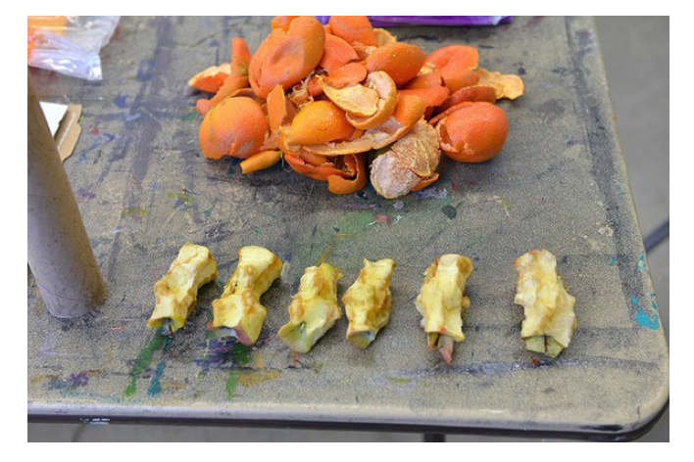Media:
Found objects, places, time
Materials:
+ Seven days of your garbage
+ A bag for storing everything
+ Camera
+ Paper and pen

Project #3: The Secret Life of Garbage
The average American produces 1,609 pounds of garbage a year, almost 4.5 pounds a day! That means 5 percent of the world’s population produces 40 percent of the world’s waste. This project is not solely about making you aware of the waste you produce; it is also about getting you to look at something ubiquitous, something we all produce and spend little time thinking about. Every day we leave behind evidence of our existence as seen through our waste. What does that say about what we need versus what we want? Do you have any idea what makes up your garbage? What can you learn about yourself and your interests, struggles, intentions, successes, and failures by looking at the objects you discard? For this project you are going to save SEVEN days’ worth of garbage. (You do not have to save perishable items like food or anything else that might be a biohazard.) Remember, you have to save everything, so you will need to carry a collection bag with you. If you go out for coffee, you have to save the cup. If someone gives you a piece of candy, you have to save the wrapper. If you floss your teeth, yes, you have to save that too—anything that would normally be thrown out, you save, whether you are at home, at school, out and about, or at a friend’s house.
At the end of the week your task is to spread all that garbage out and inventory it in any way you see fit. Look at it objectively: What do you see? What clues do you find there that speak to who you are, how you engage in the world, and what you value? Use your camera to document what you have collected. You can photograph each object separately, break your collection down into categories, or perhaps make a sculpture out of everything you have. Your photographs can be printed or viewed on a computer. After you have taken your inventory, sit quietly with your final archive and write out a description of who you are based on what you throw out. Your final piece is a combination of your writing and the photographs you made.
The results of the above projects are meant to be shared and compared with other people. It is best when you have a group commit to the projects and you can talk afterward and compare your experiences and results. After all, art is about communicating, and doing these activities together is a great way to start conversations and learn things about other people.

Artist Biography:
Nigel Poor
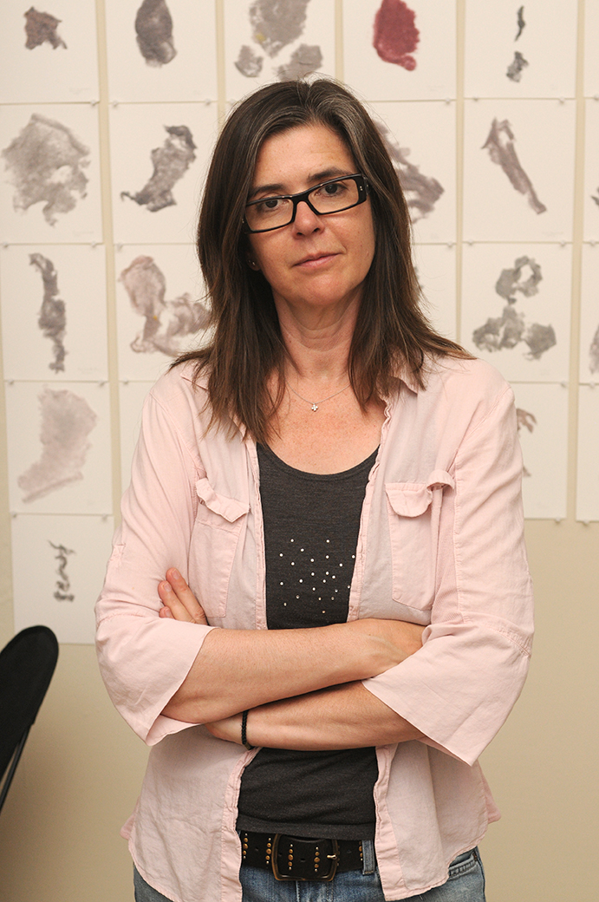Nigel Poor

Born in 1963 in Boston, Massachusetts
Currently lives in San Francisco, California
Nigel Poor is a professor of photography at California State University, Sacramento. Her work has been shown at many institutions, including the San Jose Museum of Art; Institute of Contemporary Art, San Jose; Friends of Photography; SF Camerawork; San Francisco Museum of Modern Art; San Diego Museum of Contemporary Art; Museum of Photographic Arts, San Diego; Corcoran Gallery of Art, Washington, D.C.; and Haines Gallery, San Francisco. Her work can be found in the collections of SFMOMA, the de Young Museum, San Diego Museum of Contemporary Art, and Corcoran Gallery of Art, among others. She received her BA from Bennington College and her MFA from Massachusetts College of Art.
For many years Poor’s work has explored the various ways people make a mark and leave behind evidence of their existence. In 2011 this interest led her to San Quentin State Prison, where she taught history of photography classes for the Prison University Project. The experience changed the focus of her practice and the visual presentation of her ideas. She has since moved away from being a solely visual artist working alone in the studio and now spends the majority of her “studio” time inside the prison working with a group of mostly lifers on photographic projects and producing radio stories about life inside. She is a cofounder and co–managing producer of the San Quentin Prison Report Radio Project (SQPR). In 2014 SQPR was presented with an Award of Excellence from the Society for Professional Journalism for “highlighting the stories of a prison community that outsiders rarely hear, including stories not only told from within the prison, but also produced by inmates.” In 2015 Poor was the recipient of the A Blade of Grass Fellowship for her work with the SQPR radio project.

