Chris Johanson’s How About This?:
Diagramming your life

Media:
Collage, drawing, sculpture, mixed media

Materials:
+ Paper
+ Watercolor paints
+ Watercolor brush
+ Pens

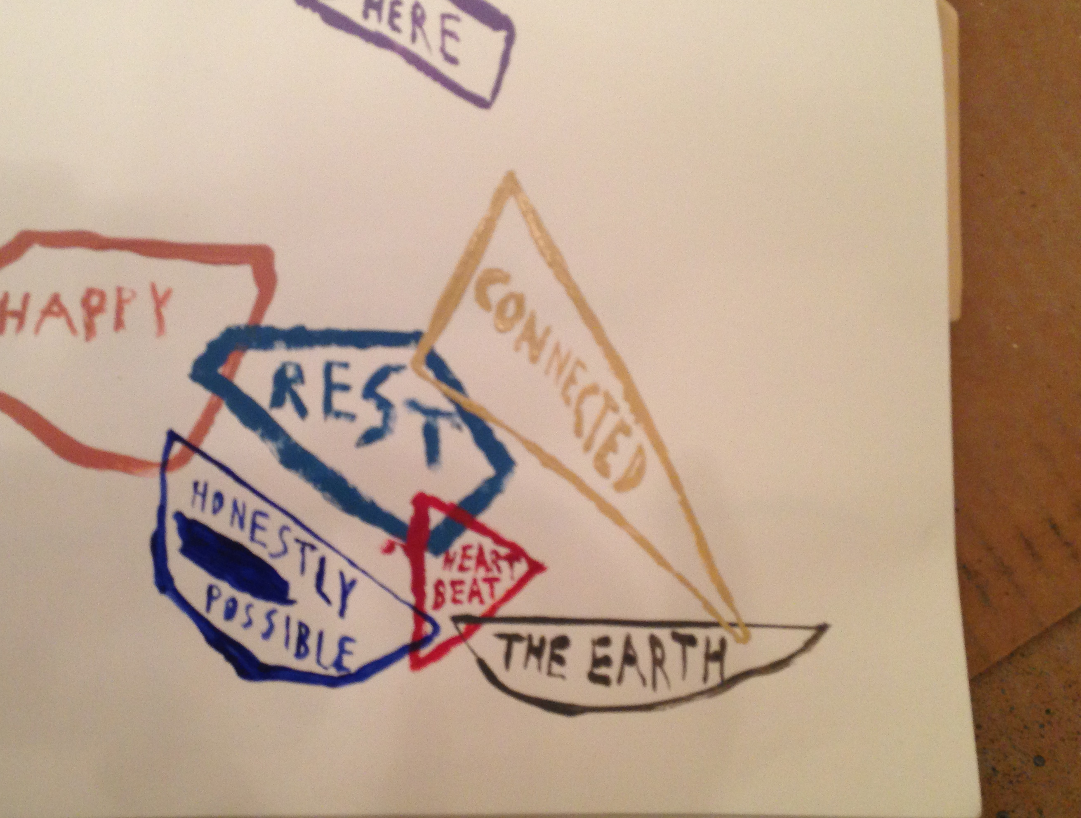
Work by Chris Johanson

Assignment: Because Everyone Lives Life Their Own Way
I learned about this in a math class for artists, but then I incorporated it into my art in my own way.
- Pick a color.
- Paint a shape.
- Write a thought inside of the shape. Continue to create shapes, with each one intersecting another, and continue to write thoughts inside of those shapes. Do this for a while, because lots of things in your life intersect.
- When you are finished, you have created conceptual art. More specifically, that’s a picture of your thoughts and your life.

Helpful Vocabulary:
Venn Diagram: A diagram that pictorially represents mathematical or logical sets as circles or closed curves within an enclosing rectangle (the universal set); common elements are represented by the areas where the circles overlap.
Conceptual Art: Art in which the idea is more important than the form or style.

Artist Biography:
Chris Johanson
Chris Johanson, Self-Portrait

Born in 1968 in San Jose, California
Currently lives in Los Angeles, California
Hi Everyone. I am a professional artist living in Los Angeles at the moment. I have been involved with art making my whole life. I am interested in all art mediums. I play music, paint, make sculptures, curate shows, etc. If you want one, you too can have a fulfilling creative life. Work hard and believe in yourself.
Wishing you the best,
Chris

