John Baldessari’s List of Ideas:
Fourteen disparate assignments

John Baldessari presents several classroom art-making ideas.
The following text is drawn from preparatory materials for Baldessari’s Cal Arts Post Studio Art: Class Assignments (optional), 1970. Spelling and punctuation match Baldessari’s original typewritten notes.
Media:
Mixed media, Photography, Video
Materials:
+ Camera
+ Paper
+ Pen or pencil
+ Video camera

Assignment #1
Make up an art game. Structure a set of rules with which to play. A physical game is not necessary; more important are the rules and their structure. Do we in life operate by rules? Does all art? Or art rules, like tenant rules or art violations.
Assignment #2
How can plants be used in art. Problem becomes how can we really get people to look freshly at plants as if they’ve never noticed them before. A few possibilities: 1. Arrange them alphabetically like books on a shelf; 2. Plant them like popsicle trees (as in child art) perpendicular to line of hill; 3. Include object among plants that is camouflaged 4. Color palm tree pink; 5. Photo found growing arrangements; 6. Or a movie on How to Plant a Plant.
Assignment #3
Pay homage to a movie star, rock musician, etc. in form of a pilgrimage visit. Photograph is required of the two of you with a personalized signed greeting by the culture hero. Or it could be to a famous person’s grave. In this case a photo of you at the grave. Person’s name on the gravestone should be visible. No signature necessary.
Assignment #4
Defenestrate objects. Photo them in mid-air.

Assignment #5
One person copies or makes-up random captions. Another person takes photos. Match photos to captions.
Assignment #6
Disguise an object to look like another object.
Assignment #7
Make up list of distractions that often occur to you. Recreate on video tape.
Assignment #8
Document change, decay, metamorphosis, changes occurring in time. Photograph same thing at various times during the day.
Assignment #9
By using movie camera to follow actions and by your observations into cassette recorder, document the movements of someone secretly for an entire day. Or have someone follow you.
Assignment #10
Photograph backs of things, underneaths of things, extreme foreshortenings, uncharacteristic views. Or trace them.
Assignment #11
Describe the visual verbally and the verbal visually.
Assignment #12
Scenarios. Do a movie from an existing, stock scenario. Or 1 person write scenario, another shoot movie. Or GRABAG scenario—everyone write 2-3 scenes, drop in box, someone pull out maybe 10 and they are shot in the order drawn out. Or everyone do their version of the grabag scenario.
Assignment #13
Repaired or patched art. Recycled. Find something broken and discarded. Perhaps in a thrift store. Mend it.
Assignment #14
Photograph of umbrella and sewing machine on an operating table. That’s Surrealism isn’t it?

Artist Biography:
John Baldessari
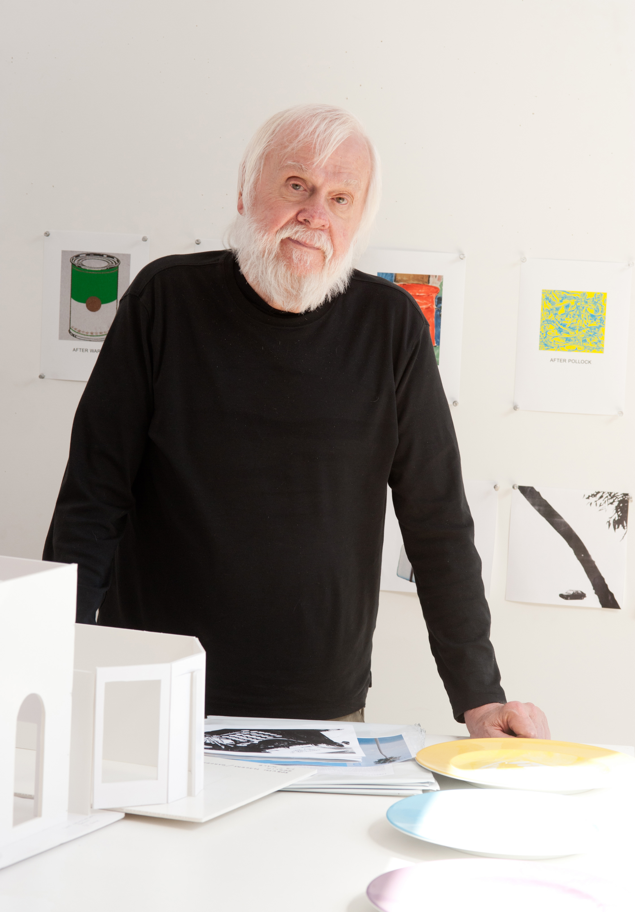Photo: Jim McHugh, © Jim McHugh

Born in 1931 in National City, California
Currently lives in Santa Monica, California; works in Venice, California
Baldessari attended San Diego State University and did post-graduate work at Otis Art Institute, Chouinard Art Institute, and the University of California, Berkeley. He taught at California Institute of the Arts in Valencia, California, from 1970 to 1988 and the University of California, Los Angeles, from 1996–2007. Baldessari's artwork, including projects such as artist books, videos, films, billboards, and public works, has been featured in more than 200 solo exhibitions and in over 1,000 group exhibitions in the U.S. and Europe. His awards and honors include memberships in the American Academy of Arts and Letters and the American Academy of Arts and Sciences, the Americans for the Arts Lifetime Achievement Award, the Rolex Mentor and Protégé Arts Initiative, the BACA International 2008, and the Golden Lion for Lifetime Achievement, awarded by La Biennale di Venezia in 2009.

